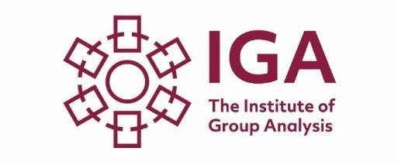
Glasgow Foundation
Course in Group Analysis
September 2024-June 2025

The Institute of Group Analysis (IGA) Foundation Course in Group Analysis has been running for over forty years and draws upon psychoanalytic theory, social science, and systems theory in its understanding of the human experience. It gives students the choice to join the course as a stand-alone or as the prerequisite for the IGA Diploma in Groupwork Practice and the Qualifying Course in Group Analysis.

Course Details:
The course will be
mainly in-person.
with 6 additional online sessions .
September 7th, 2024
October 5th, 2024
November 2nd ,2024
December 7^{th ,}2024
January 11th, 2025
February 1st, 2025
March 1st ,2025
April 5th ,2025
May 3rd ,2025
June 7th, 2025
6 Online dates will be announced at a later date.
Course Fee
Early bird (before 30/4/24) £1582
Standard Fee: £1,685
Registration fee (included in course fee and non-refundable): £250.00

Contact
Catherine Dunnet,
Glasgow Foundation Course Convenor:
GlasgowFCConvenor@groupanalysis-uk.co.uk
or
Kike Adegbola,
Training Administrator:
Training@groupanalysis-uk.co.uk
Please note: the course will run subject to sufficient applications. Closing date 30/7/24

Why Group Analysis?
Group Analysis is a powerful therapeutic medium that focuses on the relationship between the individual and the group, emphasising the essentially social nature of the human experience. As a method of treatment, group analysis recognises how emotional, behavioural and psychological phenomena emerge in the context of our social groups. Carefully constituted analytic groups have a long history of helping people with personal problems and in promoting personal development. Our philosophy is that as personal difficulties have their roots in our social relationships, groups are a prime place to explore, understand and try to resolve them.

Applications of Group Analysis
The Group Analytic approach has profound implications for group and teamwork in a wide range of health, social and educational settings e.g., refugees, homeless and displaced persons, victims of domestic violence, church groups, groups in forensic settings, leadership and organisational dynamics. It is also pertinent to understanding the dynamics of our lives in society beyond the clinical setting.

Who can apply?
The Foundation Course is open to professionals from a wide range of backgrounds who are interested in the study of group dynamics. A fundamental component of the learning takes place in small experiential groups conducted by qualified and experienced members of the IGA. In addition, the course introduces students to the principles of group analysis in clinical settings, organisations and to the wider socio-political context.

"A fascinating insight into group therapy, the dynamics of groups and,
perhaps most importantly, my own place in a group."
John, Glasgow student 2020-21

Venue: Garnethill Centre, 28 Rose Street, Glasgow G3 6RE

For more information visit our website – www.groupanalysis.org
The IGA is a charity registered in England
and Wales (280942), and in Scotland (SC040468); and is a company registered in England and Wales 01499655

